Media Analysis:
Adam Bobrow’s Technologies of the Self in Digital Identity

Xianglong Lin
45791439
COMU2150: Media and Identity

I declare that I HAVE used generative AI for this assignment,
and I have documented that use according to the requirements set out in the assessment
documentation.

Table of Contents
Introduction 3
Main Body 3
Theme 1: Self-Regulation and Self-Transformation 3
Theme 2: Power Dynamics in Digital Media 4
Theme 3: Performativity and Identity Construction 4
Conclusion 5
References 6
Appendix 7
Prompt and Response 7
Critical Evaluation 8
Refining and Enhancing the AI-Generated Responses 9
Exclusions Made and the Reasons for Omission 9

Introduction

Michel Foucault's theory of technologies of the self (1982) describes the process by which individuals regulate their own behavior, thoughts, and actions to gradually change themselves into an ideal state, in terms of happiness, wisdom, or perfection. In today's Internet age, the self-technology of social media influencers mainly manifests in presenting and shaping their own identity before a large audience. This article will focus on the digital media content of table tennis influencer Bobrow, critically exploring three core themes: self-regulation and self-transformation, power dynamics in digital media, and performativity and identity construction. This study of Bobrow's YouTube posts and tweets will showcase his highly skilled and humorous image, revealing the process of self-transformation and explaining how she constantly improves himself and interacts with a global audience on digital media.

Main Body

Theme 1: Self-Regulation and Self-Transformation

Referring to Foucault's theory of technologies of the self (1982), individuals combine external practice and internal reflection to shape and enhance their self-identity. As mentioned in the lecture material of "Big Ideas Part 1", Foucault's research (1982) emphasises the external practices and disciplines that create individual cognition. Bobrow is a well-known figure in the table tennis community, and his YouTube videos reflect this concept, such as the video "Adam vs. the Best Defender of All Time" (Bobrow, 2024), where he faces professional players and gains self-reflection and awareness. His content covers conscious self-growth, which coincides with Foucault's view (1982) that individuals must constantly transform their thoughts and change their behaviour to transform themselves.

Bobrow's YouTube content can be considered as a record and supervision of himself. Each competition is a symbolic practice of his self-transformation, and the videos are a good proof of his growth as a table tennis player. He is constantly striving for excellence, criticising, improving, and even fine-tuning his self-expression. Therefore, his strong will to face difficulties is in line with the concept of self-regulation instilled by Danaher et al. (2000), which is the continuous evaluation of one's own actions to achieve one's desires. Continuous self-improvement and development highlight the indispensability of social media in influencers' self-realisation. Being motivated is not only a public expression, but also an internal good formation.

Bobrow's self-regulation is not only in table tennis skills, but also in audience interaction and brand management, which is used to shape his public image as "The Voice of Table Tennis". This transformation process not only enhances his technical skills, but also demonstrates his initiative in implementing self-transformation strategies on digital platforms. The reflects Foucault's conclusion (1982) that self-regulation intertwines the ideals of the individual with the expectations of society.

Theme 2: Power Dynamics in Digital Media

Foucault's technologies of power also provides an important reference for rational exploration of individual behavior under social structures, with a focus on the binding force of social norms and external rules on individuals (Koopman, 2017). In the technological context of social media, power is constantly being dynamically reconfigured. The lecture materials for the 2nd week confirm the significant impact of digital media on power relations (Danaher et al., 2000), for example, platforms like YouTube enable individuals to challenge and break through traditional hierarchical divisions. In his video series "Beat Me, Win $100", Bobrow allows players of all levels to initiate challenges, promoting the more accessible nature of table tennis and breaking the monopoly of professional players in the sport. Bobrow's ability to be characterised as a key public figure in the movement also benefited from his actions that changed the power dynamics in the table tennis community.

Foucault's study of power is particularly applicable to, but not limited to, digital environments such as YouTube, as these Internet spaces give rise to new and different modes of exercising and negotiating power (deBrabander, 2017). Bobrow's unique concept and consumption style of table tennis has attracted audiences from all over the world, so he is not only a table tennis player, but also a media figure. He blurred the conventional boundaries between fans and top players, creating a new power relationship between amateurs and professionals. On his YouTube channel, you can see him competing with various players, including amateur players, professional players, and even children. It can be seen that the reconfiguration of power explains how digital influencers operate social media to shape and redefine the public authority in their field.

Theme 3: Performativity and Identity Construction

Judith Butler's performance theory (1988) claims that identity is formed through repeated actions and performances. Bobrow's presence on YouTube is also an application of this framework in shaping his public performance of the identity of "The Voice of Table Tennis". Each video represents a performance, from his humorous style to his iconic "snake-like serve", constantly refreshing and consolidating his public image.

The video "Is Gender Real?" in the 2nd week's tutorial (Wisecrack, 2015) proposes that the central idea of identity construction during performance simultaneously affects gender identity and other social identities. Bobrow's repeated table tennis challenges, humorous comments, and skill demonstrations are not only a fun narrative of entertainment, but also a consolidation and maintenance of his skilled and accessible public image.

Butler's theory (1988) makes us realise that Bobrow's identity is gradually built up through countless digital behaviors rather than being endowed with Butler's identity naturally. In addition, social media such as YouTube provides more space for interaction and feedback from the audience, further enhancing Bobrow's performative identity. The comments, likes and shares from audiences around the world are a recognition of his identity and guide his future video performance style. This process of identity construction through performative repetition and audience interaction highlights the collaborative nature of identity formation in the digital age.

Bobrow's sense of humor and way of interacting with the audience also confirms Butler's theory of performance (1988), which states that performance can challenge or reinforce social norms. Bobrow's YouTube videos are somewhere between competitive and entertaining, subverting people's traditional perceptions of athletes' images and portraying how influencers can redefine their self-image through digital performances. This corresponds to the discussion in the 2nd week about how media forms and maintains identity, and digital platforms provide a stage and opportunity for the establishment and reconstruction of public figures like Bobrow. (deBrabander, 2017)

Conclusion

Adam Bobrow's YouTube videos vividly illustrate the application of Foucault's theories of technologies of the self and Butler's performativity in contemporary digital media. By analysing the 3 core themes—self-regulation and self-transformation, power dynamics in digital media, and performativity and identity construction—this paper argues that Bobrow represents not merely a form of entertainment, but a complex process of identity formation and self-fashioning. The concepts taught in the 2nd week of this course, concerning the intricate process of identity formation and self-shaping, demonstrate how individuals like Bobrow can leverage digital media to cultivate and transform their public personas. Drawing from Foucault and Butler's theories, Bobrow's digital existence exemplifies the immense potential of social media as a platform for power negotiation, identity performance, and self-regulation.

References
Bobrow, A. (2024, August 9). Adam vs. the best defender of all time [Video]. YouTube.
https://www.youtube.com/watch?v=S7jamqxWEv8
Butler, J. (1988). Performative acts and gender constitution: An essay in phenomenology and
feminist theory. Theatre Journal, 40(4), 519-531. https://doi.org/10.2307/3207893
Danaher, G., Schirato, T., & Webb, J. (2000). Understanding Foucault. Allen & Unwin.
https://ebookcentral.proquest.com/lib/uql/detail.action?docID=258703
deBrabander, F. (2017, January 3). How baring and sharing online increases social conformity.
Aeon. https://aeon.co/essays/how-baring-and-sharing-online-increases-social-conformity
Foucault, M. (1982). Technologies of the self. [Lecture]. Foucault.info.
https://foucault.info/documents/foucault.technologiesOfSelf.en/
Koopman, C. (2017, March 15). Why Foucault's work on power is more important than ever.
Aeon. https://aeon.co/essays/why-foucaults-work-on-power-is-more-important-than-ever
Wisecrack. (2015, June 28). Is gender real? – 8-bit philosophy [Video]. YouTube.
https://www.youtube.com/watch?v=gkilQ87UUj8

Appendix

Prompt and Response:

- Prompt 1: Provide a summary that combines the theories of Foucault and Butler with the context of digital media, focusing on identity construction and self-regulation.

Response 1:
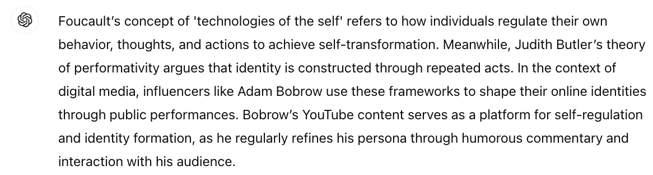

- Prompt 2: What are some examples of power dynamics and performance concepts in Adam Bobrow's YouTube content?

Response 2:
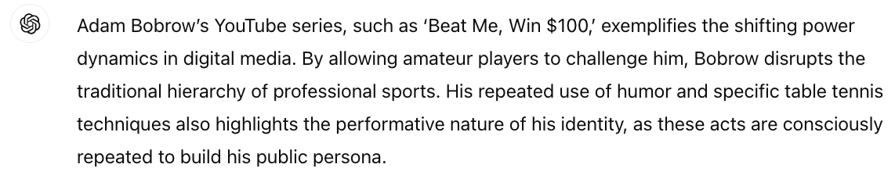

- Prompt 3: Explain how Foucault's concept of 'biopower' applies to Adam Bobrow's digital presence on YouTube, especially how he influences the behaviour of his audience.

Response 3:
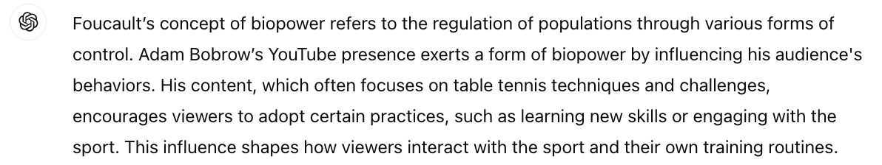

- Prompt 4: How can we extend Judith Butler's concept of 'gender performativity' beyond gender to discuss how influencers like Adam Bober construct their identities through online repetition?

Response 4:
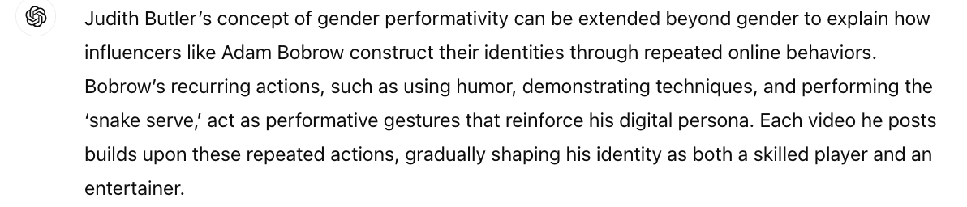

Critical Evaluation:

- Response 1: AI provides a brief description of the theories of Foucault and Butler on digital media and identity construction. However, deeper and more specific discussions should be conducted around these theories and Bobrow's YouTube content and corresponding video examples as evidence for practice. Therefore, I will explain the relationship between theory and practice in a comprehensive way by citing specific and detailed YouTube videos of Bobrow.

- Response 2: Although this response captures some of the power dynamics and performativity contained in Bobrow's social media, it also lacks specific discussion of how these dynamics relate to Bobrow and his audience's following. Therefore, I have added appropriate supplements to explain that the challenge set by Bobrow not only makes table tennis more accessible to the public, but also changes the audience's traditional perception of power and authority in the table tennis world.

- Response 3: AI's interpretation of ‘biopower’ is correct but somewhat general, failing to explain specifically how Bobrow's social media content drives the audience's behavior beyond table tennis skills. I explained that Bobrow's self-criticism, improvement, and even fine-tuning of excellence, all of these demonstrate his deeper influence on the behaviour of the audience. Thus, the audience's comments, likes, and shares have also become a positive response to Bobrow's identity recognition.

- Response 4: The application of Butler's performance concept to Bobrow's Internet image construction is correct, but it is not enough to clarify the role of audience feedback in reinforcing these behaviours. I added an interactive analysis of Bobrow's videos, especially how the audience's feedback can be reflected in his future content self-expression.

Refining and Enhancing the AI-Generated Responses

In assessing the responses of AI, my focus tended to be on judging how well AI applied the theories of Foucault and Butler to Bobrow's YouTube videos. For Response 1, the theoretical summary of AI was concise and clear, and was a favorable breakthrough in analysis. Although there were no specific examples in the response to more vividly demonstrate the practical application of these theories. So, I kept the theoretical framework, and added Bobrow's YouTube video as an example for evidence. For instance, I described how Bobrow's humor and technical skills in the table tennis challenges reflected self-regulation and performance. This addition would provide a more complete answer and strengthen the argument.

In Response 2, AI effectively identified the power dynamics and performativity covered in the Bobrow’s video, but similarly did not provide deeper analysis of how these dynamics affect individuals and his audiences. I reserved my basic interpretation of this AI response, but enhanced it by discussing how Bobrow's challenges had altered the traditional understanding of power and authority within the table tennis community. I used Bobrow's redefinition of professional players and amateurs to improve text relevance and enrich details. The corresponding modifications reflected both the existence of power dynamics and Bobrow's deeper influence on the audience.

Similarly, in Response 3, the AI explanation of ‘biopower’ was correct but lacked details about changing audience behaviour. I retained the perspectives and ideas provided by AI, and introduced Bobrow's guidance on his audience's table tennis skills to increase the pertinence of the argument and clarify the interaction between theory and the actual behaviour of the audience.

Exclusions Made and the Reasons for Omission

In most cases, AI responses were relatively general and repetitive, so I excluded this type of response. For example, in Response 2, AI again revealed that Bobrow's table tennis challenges made table tennis more accessible, but there were too few new ideas. Therefore, I had excluded repetitive expressions and focused on exploring how these challenges had changed the audience's perception of the power structure in table tennis, in order to refresh and consolidate the argument.

In addition, in Response 4, although the AI's explanation of the construction of performative identity was correct, how the audience feedback reinforced Bobrow's identity was unclear. So I removed the narrative of audience interaction and replaced it with a detailed explanation of the role of audience feedback in shaping Bobrow's Internet image.

